LAURA KOERNER
US Navy Veteran Chairwoman

KEVIN BARBER
US Army Veteran Vice Chair

KIMBERLEE SHANEYFELT
Colonel, US Air Force (Retired) Secretary

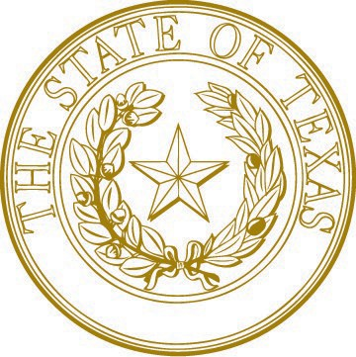
TEXAS VETERANS COMMISSION
MIKE P. HERNANDEZ
Corporal, US Marine Corps (Retired) Member

MARY LOPEZ DALE
US Army Veteran Member

THOMAS P. PALLADINO
Colonel, US Army (Retired) Executive Director

Veteran Services Advisory Committee Meeting Agenda
Wednesday, May 11, 2022
2:00 p.m.
Stephen F. Austin Building – HQ Conference Room
1700 North Congress Ave, Suite 800, Austin, Texas 78701
https://attendee.gotowebinar.com/register/1083969354038702862

- Call to order.
- Roll call of Committee members.
- Public comment.
- Approve the minutes of the VSAC meeting held February 9, 2022.
- Review TVC’s response to the Justice Involved Veterans recommendations.
- Discuss and provide recommendations to enhance Communications and Outreach of TVC services to veterans, their families, and surviving spouses.
  - Claims, Education, and Employment Services.
- Discussion on agenda items, date/time, and location for the next Veteran Services Advisory Committee or Appropriate Subcommittee meeting.
- Adjournment.

Members of the Public needing assistance with access to this meeting are requested to contact Elaine Zavala, Director of Communications, at (737) 237-3571, two (2) working days prior to the meeting so that appropriate assistance and/or arrangements can be made to assist.

1700 N. Congress Avenue, Austin, Texas 78701-1496 | P.O. Box 12277, Austin, Texas 78711-2277 Phone: 512/463-6564 | Fax: 512/475-2395 | E-Mail: info@tvc.texas.gov | Web: www.tvc.texas.gov An Equal Opportunity Employer

